Annex 1

Complementary document to the results of the Serbian Second National Forest Inventory -
-Land Cover Change assessment using the FAO Collect Earth tool-.
From 2000 to 2019

Project: GCP/SRB/002/GFF: Contribution of sustainable forest management to a low emission and resilient development in Serbia (FSP)

Prepared by:
Anibal Cuchietti (FAO, International Forestry Consultant)
David Morales-Hidalgo (Forestry Officer)
Javier García (International Forestry Consultant)

November 2023

Table of Contents
I. Background 4
II. About this report 5
III. Land cover vs Land Use 5
IV. Methodology 6
V. Results 6
VI. Comparation of the results with other sources of information on Serbia forest cover. 17
VII. Final comments 18
VIII. Annex 18

Background
The Food and Agriculture Organization (FAO) has partnered with the government of Serbia to implement the project GCP/SRB/002/GFF, “Contribution of Sustainable Forest Management to Low Emission and Resilient Development,” which has been approved by the Global Environmental Fund. The report of this mission is part of the overall implementation of this project.
According to the Forest Resources Assessment, Serbia is covered by forests, with an area of 2,722,218.84 hectares, accounting for approximately 31.1% of the country’s total land. The forest sector contributed 1.3% to the national GDP in 2019, including the value added by forestry and logging and the manufacture of wood and wood products. Over 1,498,000 hectares of forests are used for productive purposes. Regarding ownership, 53% of the forests are owned by the state, while the rest are privately owned.
The location of forests in hilly or mountainous regions poses challenges for effective forest management. Despite these challenges, Serbian forests are rich in genetic, species, and ecosystem diversity. The forests and shrublands featuring endemic woody plants are significant.
Serbia’s most significant environmental impacts are deforestation, forest degradation, and biodiversity loss where illegal logging, forest fires, and impacts from the agriculture are the major drivers of this impacts.
Serbia's current national forest policy lacks quantified targets and specific guidance on forest carbon management and biodiversity conservation. There is a lack of comprehensive information management systems and limited capacities among institutions responsible for sustainable forest management. The project “Contribution of Sustainable Forest Management to a Low Emission and Resilient Development” aims to address these barriers and promote sustainable forest management by improving information systems, bringing 80,000 hectares of forests under sustainable management, and incorporating multi-sectoral priorities, including carbon sequestration and biodiversity conservation.
Under Component 1 of the project “Enabling Environment for Multifunctional Sustainable Forest Management,” an Integrated Forest Information System was established to provide users with easy access to information for both strategic and operational purposes. Output 1, “Methodology for Forest and Biodiversity Information Collection and Management,” has introduced a novel approach for data collection and analysis.
As part of Output 1, FAO supports Serbia in implementing a new National Forest Inventory Sampling Design, utilizing a two-phase sampling method. The first phase involves an analysis of land cover of all sampling points using a 1km x 1km grid. This information was collected using visual interpretation of high-resolution free imagery available on the Google Earth and Bing platforms using the FAO - Collect Earth (CE) tool, and its results were used as a post-stratification variable for the second sampling phase.
The first phase of data collection had also included historical records of the land cover changes in Serbia, from the year 2000 to 2018. For this historical analysis, IPCC land cover classes were used: Cropland, Forest, Grassland, Other land, Settlement, and Wetland. It is essential to highlight that the IPCC classes differ from the land cover classes used in the Forest Resources Assessment (FRA) 2020.

About this report
This report will present the remote sensing data analysis results on the historical land cover analysis in Serbia from 2000 to 2019.
The report is based in the data collected using the Collect Earth tool⁴, based on the methodology defined for the project.
It is focus on land cover analysis, which differs from the analysis presented in the Annex 2 that refers to Land use analysis based on the two-phase sampling design that takes in consideration the field inventory and the remote sensing information presented in this report.
The information presented in this report, was not included in the NFI Report prepared by FAO 2023 about the results of the field inventory, using only field data.

Land cover vs Land Use
Land is accounted for in two ways: as biogeographical land cover and as socioeconomic land use. The land cover indicates the visible surface of the land, such as crops, grass, water, broad-leaved forest, or built-up area. Land use indicates the socioeconomic purpose for which the land is used, such as agriculture, forestry, recreation, or residential use. Data on land cover and land use are essential for observing and managing a range of key environmental and socioeconomic trends, many of which are linked to the sustainable use of resources and climate change.
It is important to understand the concept of Land Cover vs. Land Use when the Forest Cover/area is defined. This understanding is essential when estimating the forest cover/use of a region, country, or at the global level. It is highly relevant to understand the differences between the information provided in this report on land cover assessment if it is compared with the information provided by the additional report on the forest area calculated using the data from the field inventory, where the forest use is recorded.
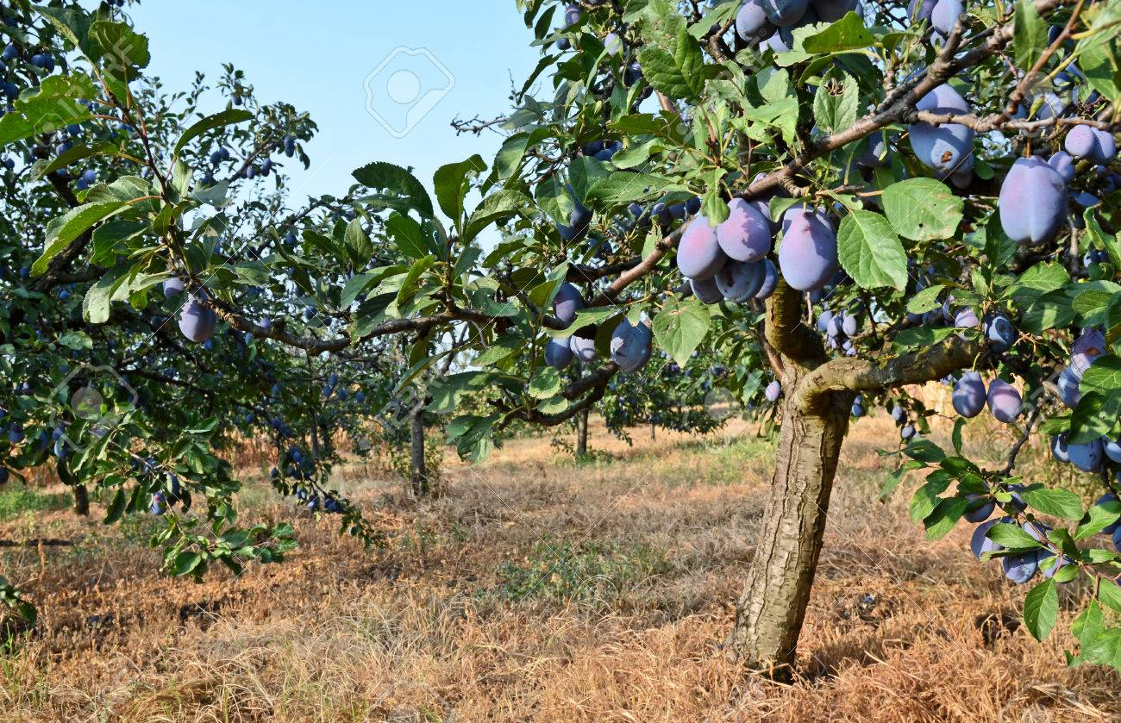 | 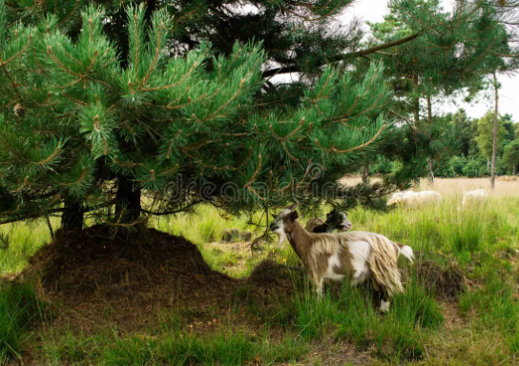
Figure 1: Two illustrative example of areas that can be classified as Forest Cover using remote sensing, but as Agriculture Land use, since the principal purpose is agriculture (plum production), or livestock.

Methodology
The methodology used for data collection on the historical IPCC land cover classes is included in the second national forest inventory project document method.
For the analysis of the information, a Simple Random Sampling estimator was used to provide the study of the results.

Results
The main results of the historical analysis of the IPCC land cover class changes in Serbia between 2000 and 2019 and by regions are included in Table 1, Table 2, Table 3, Table 4, Table 5 and Table 6.

Table 1: Percentage of land cover per the IPCC land cover classes in Serbia, between 2000 and 2019, with the percentage of standard error (SE) for each land cover class and year.
 | CROPLAND |  | FOREST |  | GRASSLAND |  |  | OTHERLAND |  | SETTLEMENT |  | WETLAND |  | NO_CLASS
YEAR | % | SE_% | % | SE_% | % | SE_% | % |  | SE_% | % | SE_% | % | SE_% | % | SE_%
2000 | 45.8 | 0.1 | 39.0 | 0.1 | 8.2 | 0.2 | 0.3 |  | 0.2 | 4.8 | 0.2 | 1.1 | 0.2 | 0.8 | 0.2
2001 | 45.8 | 0.1 | 39.0 | 0.1 | 8.2 | 0.2 | 0.3 |  | 0.2 | 4.8 | 0.2 | 1.1 | 0.2 | 0.8 | 0.2
2002 | 45.8 | 0.1 | 39.0 | 0.1 | 8.2 | 0.2 | 0.3 |  | 0.2 | 4.8 | 0.2 | 1.1 | 0.2 | 0.8 | 0.2
2003 | 45.8 | 0.1 | 39.0 | 0.1 | 8.2 | 0.2 | 0.3 |  | 0.2 | 4.8 | 0.2 | 1.1 | 0.2 | 0.8 | 0.2
2004 | 45.8 | 0.1 | 39.0 | 0.1 | 8.2 | 0.2 | 0.3 |  | 0.2 | 4.8 | 0.2 | 1.1 | 0.2 | 0.8 | 0.2
2005 | 45.8 | 0.1 | 39.0 | 0.1 | 8.2 | 0.2 | 0.3 |  | 0.2 | 4.8 | 0.2 | 1.1 | 0.2 | 0.8 | 0.2
2006 | 45.8 | 0.1 | 39.0 | 0.1 | 8.2 | 0.2 | 0.3 |  | 0.2 | 4.8 | 0.2 | 1.0 | 0.2 | 0.8 | 0.2
2007 | 45.8 | 0.1 | 39.0 | 0.1 | 8.2 | 0.2 | 0.3 |  | 0.2 | 4.8 | 0.2 | 1.0 | 0.2 | 0.8 | 0.2
2008 | 45.8 | 0.1 | 39.0 | 0.1 | 8.2 | 0.2 | 0.3 |  | 0.2 | 4.8 | 0.2 | 1.0 | 0.2 | 0.8 | 0.2
2009 | 45.8 | 0.1 | 39.0 | 0.1 | 8.2 | 0.2 | 0.3 |  | 0.2 | 4.8 | 0.2 | 1.0 | 0.2 | 0.8 | 0.2
2010 | 45.8 | 0.1 | 39.0 | 0.1 | 8.2 | 0.2 | 0.3 |  | 0.2 | 4.8 | 0.2 | 1.0 | 0.2 | 0.8 | 0.2
2011 | 45.8 | 0.1 | 39.0 | 0.1 | 8.2 | 0.2 | 0.3 |  | 0.2 | 4.8 | 0.2 | 1.0 | 0.2 | 0.8 | 0.2
2012 | 45.8 | 0.1 | 39.1 | 0.1 | 8.1 | 0.2 | 0.3 |  | 0.2 | 4.8 | 0.2 | 1.0 | 0.2 | 0.8 | 0.2
2013 | 45.8 | 0.1 | 39.1 | 0.1 | 8.1 | 0.2 | 0.3 |  | 0.2 | 4.8 | 0.2 | 1.0 | 0.2 | 0.8 | 0.2
2014 | 45.7 | 0.1 | 39.2 | 0.1 | 8.1 | 0.2 | 0.3 |  | 0.2 | 4.8 | 0.2 | 1.0 | 0.2 | 0.8 | 0.2
2015 | 45.7 | 0.1 | 39.2 | 0.1 | 8.1 | 0.2 | 0.3 |  | 0.2 | 4.8 | 0.2 | 1.1 | 0.2 | 0.8 | 0.2
2016 | 45.7 | 0.1 | 39.2 | 0.1 | 8.0 | 0.2 | 0.3 |  | 0.2 | 4.8 | 0.2 | 1.1 | 0.2 | 0.8 | 0.2
2017 | 45.7 | 0.1 | 39.3 | 0.1 | 8.0 | 0.2 | 0.3 |  | 0.2 | 4.8 | 0.2 | 1.1 | 0.2 | 0.8 | 0.2
2018 | 45.7 | 0.1 | 39.3 | 0.1 | 8.0 | 0.2 | 0.3 |  | 0.2 | 4.8 | 0.2 | 1.1 | 0.2 | 0.8 | 0.2
2019 | 45.7 | 0.1 | 39.3 | 0.1 | 8.0 | 0.2 | 0.3 |  | 0.2 | 4.8 | 0.2 | 1.1 | 0.2 | 0.8 | 0.2
*SE_%= Standard Error of the Percentage
** Note: IPCC forest land cover types differ from NFI2 land use, including FAO -FRA classes. Here, Forest cover might include other wooded land defined in FAO-FRA classes.

Table 2: Hectares of land cover per the IPCC land cover classes in Serbia, between 2000 and 2019, with the percentage standard error (SE) for each land cover class and year.
 | CROPLAND |  | FOREST |  | GRASSLAND |  | OTHERLAND |  | SETTLEMENT |  | WETLAND |  | NO_CLASS
YEAR | ha | SE_ha | ha | SE_ha | ha | SE_ha | ha | SE_ha | ha | SE_ha | ha | SE_ha | ha | SE_ha
2000 | 3554330.1 | 4698.4 | 3023231.9 | 4241.4 | 635891.9 | 1094.3 | 23090.1 | 41.4 | 373094.6 | 653.8 | 81653.5 | 145.9 | 63992.0 | 114.5
2001 | 3554330.1 | 4698.4 | 3023231.9 | 4241.4 | 635891.9 | 1094.3 | 23090.1 | 41.4 | 373094.6 | 653.8 | 81653.5 | 145.9 | 63992.0 | 114.5
2002 | 3554305.0 | 4698.3 | 3023256.9 | 4241.4 | 635891.9 | 1094.3 | 23090.1 | 41.4 | 373094.6 | 653.8 | 81653.5 | 145.9 | 63992.0 | 114.5
2003 | 3554255.0 | 4698.3 | 3023357.0 | 4241.5 | 635841.8 | 1094.2 | 23090.1 | 41.4 | 373094.6 | 653.8 | 81653.5 | 145.9 | 63992.0 | 114.5
2004 | 3554180.0 | 4698.2 | 3023507.1 | 4241.7 | 635766.8 | 1094.1 | 23090.1 | 41.4 | 373094.6 | 653.8 | 81653.5 | 145.9 | 63992.0 | 114.5
2005 | 3554004.8 | 4698.1 | 3023657.2 | 4241.8 | 635716.7 | 1094.0 | 23190.2 | 41.6 | 373094.6 | 653.8 | 81628.5 | 145.8 | 63992.0 | 114.5
2006 | 3553804.7 | 4698.0 | 3024257.6 | 4242.4 | 635491.6 | 1093.6 | 23215.2 | 41.6 | 373094.6 | 653.8 | 81428.4 | 145.5 | 63992.0 | 114.5
2007 | 3553704.6 | 4697.9 | 3024557.8 | 4242.7 | 635166.4 | 1093.1 | 23265.3 | 41.7 | 373169.6 | 653.9 | 81428.4 | 145.5 | 63992.0 | 114.5
2008 | 3553604.6 | 4697.8 | 3024732.9 | 4242.8 | 635066.3 | 1092.9 | 23290.3 | 41.8 | 373194.6 | 653.9 | 81403.4 | 145.4 | 63992.0 | 114.5
2009 | 3553379.4 | 4697.6 | 3025133.1 | 4243.2 | 634841.2 | 1092.5 | 23290.3 | 41.8 | 373244.7 | 654.0 | 81403.4 | 145.4 | 63992.0 | 114.5
2010 | 3552879.1 | 4697.3 | 3026534.1 | 4244.6 | 633840.5 | 1090.9 | 23340.3 | 41.9 | 373294.7 | 654.1 | 81403.4 | 145.4 | 63992.0 | 114.5
2011 | 3552103.6 | 4696.7 | 3027584.7 | 4245.6 | 632964.9 | 1089.4 | 23840.6 | 42.8 | 373394.8 | 654.3 | 81403.4 | 145.4 | 63992.0 | 114.5
2012 | 3550277.4 | 4695.3 | 3031312.2 | 4249.1 | 630813.5 | 1085.9 | 24040.8 | 43.1 | 373469.8 | 654.4 | 81378.3 | 145.4 | 63992.0 | 114.5
2013 | 3548826.4 | 4694.2 | 3033763.8 | 4251.5 | 629112.4 | 1083.1 | 24566.1 | 44.1 | 373644.9 | 654.7 | 81378.3 | 145.4 | 63992.0 | 114.5
2014 | 3547350.5 | 4693.0 | 3037066.0 | 4254.6 | 626886.0 | 1079.4 | 24716.2 | 44.3 | 373870.1 | 655.1 | 81403.4 | 145.4 | 63992.0 | 114.5
2015 | 3546950.2 | 4692.7 | 3038767.1 | 4256.2 | 625034.7 | 1076.4 | 24791.3 | 44.5 | 374145.3 | 655.6 | 81603.5 | 145.8 | 63992.0 | 114.5
2016 | 3544948.9 | 4691.2 | 3042894.8 | 4260.1 | 622708.2 | 1072.6 | 24816.3 | 44.5 | 374370.4 | 656.0 | 81553.5 | 145.7 | 63992.0 | 114.5
2017 | 3543147.7 | 4689.8 | 3046897.4 | 4263.9 | 620131.5 | 1068.3 | 25066.4 | 44.9 | 374545.5 | 656.2 | 81503.4 | 145.6 | 63992.0 | 114.5
2018 | 3541921.9 | 4688.9 | 3049198.9 | 4266.1 | 618205.3 | 1065.1 | 25441.7 | 45.6 | 375045.9 | 657.1 | 81478.4 | 145.6 | 63992.0 | 114.5
2019 | 3541646.7 | 4688.7 | 3049499.1 | 4266.4 | 617805.0 | 1064.5 | 25541.7 | 45.8 | 375246.0 | 657.4 | 81553.5 | 145.7 | 63992.0 | 114.5
*SE_%= Standard Error of the hectare
** Note: IPCC forest land cover types differ from NFI2 land use, including FAO -FRA classes. Here, Forest cover might include other wooded land defined in FAO-FRA classes.

Table 3: Percentage of land cover per the IPCC land cover classes in Central Serbia, between 2000 and 2019, with the percentage of standard error (SE) for each land cover class and year.
 | CROPLAND |  | FOREST |  | GRASSLAND |  |  | OTHERLAND |  | SETTLEMENT |  | WETLAND |  | NO_CLASS
YEAR | % | SE_% | % | SE_% | % | SE_% | % |  | SE_% | % | SE_% | % | SE_% | % | SE_%
2000 | 32.0 | 0.2 | 50.9 | 0.1 | 11.0 | 0.2 | 0.3 |  | 0.2 | 5.0 | 0.2 | 0.8 | 0.2 | 0.0 | 0.2
2001 | 32.0 | 0.2 | 50.9 | 0.1 | 11.0 | 0.2 | 0.3 |  | 0.2 | 5.0 | 0.2 | 0.8 | 0.2 | 0.0 | 0.2
2002 | 32.0 | 0.2 | 50.9 | 0.1 | 11.0 | 0.2 | 0.3 |  | 0.2 | 5.0 | 0.2 | 0.8 | 0.2 | 0.0 | 0.2
2003 | 32.0 | 0.2 | 50.9 | 0.1 | 11.0 | 0.2 | 0.3 |  | 0.2 | 5.0 | 0.2 | 0.8 | 0.2 | 0.0 | 0.2
2004 | 32.0 | 0.2 | 50.9 | 0.1 | 11.0 | 0.2 | 0.3 |  | 0.2 | 5.0 | 0.2 | 0.8 | 0.2 | 0.0 | 0.2
2005 | 32.0 | 0.2 | 50.9 | 0.1 | 11.0 | 0.2 | 0.3 |  | 0.2 | 5.0 | 0.2 | 0.8 | 0.2 | 0.0 | 0.2
2006 | 32.0 | 0.2 | 50.9 | 0.1 | 11.0 | 0.2 | 0.3 |  | 0.2 | 5.0 | 0.2 | 0.8 | 0.2 | 0.0 | 0.2
2007 | 32.0 | 0.2 | 50.9 | 0.1 | 11.0 | 0.2 | 0.3 |  | 0.2 | 5.0 | 0.2 | 0.8 | 0.2 | 0.0 | 0.2
2008 | 32.0 | 0.2 | 50.9 | 0.1 | 11.0 | 0.2 | 0.3 |  | 0.2 | 5.0 | 0.2 | 0.8 | 0.2 | 0.0 | 0.2
2009 | 32.0 | 0.2 | 50.9 | 0.1 | 11.0 | 0.2 | 0.3 |  | 0.2 | 5.0 | 0.2 | 0.8 | 0.2 | 0.0 | 0.2
2010 | 32.0 | 0.2 | 51.0 | 0.1 | 10.9 | 0.2 | 0.3 |  | 0.2 | 5.0 | 0.2 | 0.8 | 0.2 | 0.0 | 0.2
2011 | 32.0 | 0.2 | 51.0 | 0.1 | 10.9 | 0.2 | 0.3 |  | 0.2 | 5.0 | 0.2 | 0.8 | 0.2 | 0.0 | 0.2
2012 | 32.0 | 0.2 | 51.0 | 0.1 | 10.9 | 0.2 | 0.4 |  | 0.2 | 5.0 | 0.2 | 0.8 | 0.2 | 0.0 | 0.2
2013 | 31.9 | 0.2 | 51.1 | 0.1 | 10.9 | 0.2 | 0.4 |  | 0.2 | 5.0 | 0.2 | 0.8 | 0.2 | 0.0 | 0.2
2014 | 31.9 | 0.2 | 51.1 | 0.1 | 10.8 | 0.2 | 0.4 |  | 0.2 | 5.0 | 0.2 | 0.8 | 0.2 | 0.0 | 0.2
2015 | 31.9 | 0.2 | 51.2 | 0.1 | 10.8 | 0.2 | 0.4 |  | 0.2 | 5.0 | 0.2 | 0.8 | 0.2 | 0.0 | 0.2
2016 | 31.9 | 0.2 | 51.2 | 0.1 | 10.7 | 0.2 | 0.4 |  | 0.2 | 5.0 | 0.2 | 0.8 | 0.2 | 0.0 | 0.2
2017 | 31.8 | 0.2 | 51.3 | 0.1 | 10.7 | 0.2 | 0.4 |  | 0.2 | 5.0 | 0.2 | 0.8 | 0.2 | 0.0 | 0.2
2018 | 31.8 | 0.2 | 51.4 | 0.1 | 10.7 | 0.2 | 0.4 |  | 0.2 | 5.0 | 0.2 | 0.8 | 0.2 | 0.0 | 0.2
2019 | 31.8 | 0.2 | 51.4 | 0.1 | 10.7 | 0.2 | 0.4 |  | 0.2 | 5.0 | 0.2 | 0.8 | 0.2 | 0.0 | 0.2
*SE_%= Standard Error of the Percentage
** Note: IPCC forest land cover types differ from NFI2 land use, including FAO -FRA classes. Here, Forest cover might include other wooded land defined in FAO-FRA classes.

Table 4: Hectares of land cover per the IPCC land cover classes in Central Serbia, between 2000 and 2019, with the percentage standard error (SE) for each land cover class and year.
 | CROPLAND |  | FOREST |  | GRASSLAND |  | OTHERLAND |  | SETTLEMENT |  | WETLAND |  | NO_CLASS
YEAR | ha | SE_ha | ha | SE_ha | ha | SE_ha | ha | SE_ha | ha | SE_ha | ha | SE_ha | ha | SE_ha
2000 | 1792592.5 | 3124.6 | 2847741.5 | 4219.3 | 614223.6 | 1225.4 | 18710.6 | 39.5 | 278683.2 | 574.4 | 43199.5 | 91.0 | 75.0 | 0.2
2001 | 1792592.5 | 3124.6 | 2847741.5 | 4219.3 | 614223.6 | 1225.4 | 18710.6 | 39.5 | 278683.2 | 574.4 | 43199.5 | 91.0 | 75.0 | 0.2
2002 | 1792567.5 | 3124.6 | 2847766.5 | 4219.4 | 614223.6 | 1225.4 | 18710.6 | 39.5 | 278683.2 | 574.4 | 43199.5 | 91.0 | 75.0 | 0.2
2003 | 1792517.5 | 3124.5 | 2847866.5 | 4219.4 | 614173.6 | 1225.3 | 18710.6 | 39.5 | 278683.2 | 574.4 | 43199.5 | 91.0 | 75.0 | 0.2
2004 | 1792467.5 | 3124.5 | 2847991.6 | 4219.5 | 614098.6 | 1225.1 | 18710.6 | 39.5 | 278683.2 | 574.4 | 43199.5 | 91.0 | 75.0 | 0.2
2005 | 1792292.4 | 3124.2 | 2848141.7 | 4219.6 | 614048.6 | 1225.0 | 18810.7 | 39.7 | 278683.2 | 574.4 | 43174.5 | 90.9 | 75.0 | 0.2
2006 | 1792092.2 | 3124.0 | 2848742.0 | 4220.0 | 613823.4 | 1224.6 | 18835.7 | 39.8 | 278683.2 | 574.4 | 42974.4 | 90.5 | 75.0 | 0.2
2007 | 1792017.2 | 3123.9 | 2849042.2 | 4220.3 | 613498.2 | 1224.0 | 18885.7 | 39.9 | 278733.2 | 574.5 | 42974.4 | 90.5 | 75.0 | 0.2
2008 | 1791917.1 | 3123.7 | 2849217.3 | 4220.4 | 613398.2 | 1223.8 | 18885.7 | 39.9 | 278758.2 | 574.5 | 42974.4 | 90.5 | 75.0 | 0.2
2009 | 1791792.1 | 3123.6 | 2849567.5 | 4220.6 | 613173.1 | 1223.4 | 18885.7 | 39.9 | 278758.2 | 574.5 | 42974.4 | 90.5 | 75.0 | 0.2
2010 | 1791291.8 | 3122.9 | 2850943.3 | 4221.6 | 612197.5 | 1221.6 | 18935.7 | 40.0 | 278808.3 | 574.6 | 42974.4 | 90.5 | 75.0 | 0.2
2011 | 1790591.4 | 3122.0 | 2851943.8 | 4222.3 | 611322.0 | 1219.9 | 19411.0 | 41.0 | 278908.3 | 574.8 | 42974.4 | 90.5 | 75.0 | 0.2
2012 | 1788790.4 | 3119.6 | 2855671.0 | 4225.0 | 609145.8 | 1215.8 | 19611.1 | 41.4 | 278958.3 | 574.9 | 42974.4 | 90.5 | 75.0 | 0.2
2013 | 1787364.6 | 3117.7 | 2858197.4 | 4226.8 | 607419.8 | 1212.6 | 20086.4 | 42.4 | 279108.4 | 575.2 | 42974.4 | 90.5 | 75.0 | 0.2
2014 | 1785913.7 | 3115.7 | 2861499.3 | 4229.1 | 605218.5 | 1208.5 | 20236.5 | 42.7 | 279283.5 | 575.6 | 42999.4 | 90.6 | 75.0 | 0.2
2015 | 1785538.5 | 3115.2 | 2863225.2 | 4230.3 | 603367.5 | 1205.0 | 20286.5 | 42.8 | 279558.7 | 576.1 | 43174.5 | 90.9 | 75.0 | 0.2
2016 | 1783612.4 | 3112.7 | 2867352.6 | 4233.2 | 601066.2 | 1200.7 | 20261.5 | 42.8 | 279733.8 | 576.5 | 43124.5 | 90.8 | 75.0 | 0.2
2017 | 1781811.4 | 3110.2 | 2871354.9 | 4236.0 | 598489.7 | 1195.8 | 20536.7 | 43.3 | 279883.9 | 576.8 | 43074.5 | 90.7 | 75.0 | 0.2
2018 | 1780635.7 | 3108.7 | 2873681.2 | 4237.6 | 596538.6 | 1192.2 | 20886.9 | 44.1 | 280359.1 | 577.7 | 43049.4 | 90.7 | 75.0 | 0.2
2019 | 1780410.6 | 3108.4 | 2873981.3 | 4237.8 | 596138.4 | 1191.4 | 20986.9 | 44.3 | 280534.2 | 578.1 | 43099.5 | 90.8 | 75.0 | 0.2
*SE_%= Standard Error of the hectare
** Note: IPCC forest land cover types differ from NFI2 land use, including FAO -FRA classes. Here, Forest cover might include other wooded land defined in FAO-FRA classes.

Table 5: Percentage of land cover per the IPCC land cover classes in Vojvodina, between 2000 and 2019, with the percentage of standard error (SE) for each land cover class and year.
 | CROPLAND |  | FOREST |  | GRASSLAND |  |  | OTHERLAND |  | SETTLEMENT |  | WETLAND |  | NO_CLASS
YEAR | % | SE_% | % | SE_% | % | SE_% | % |  | SE_% | % | SE_% | % | SE_% | % | SE_%
2000 | 81.6 | 0.1 | 8.1 | 0.3 | 1.0 | 0.3 | 0.2 |  | 0.3 | 4.4 | 0.3 | 1.8 | 0.3 | 3.0 | 0.3
2001 | 81.6 | 0.1 | 8.1 | 0.3 | 1.0 | 0.3 | 0.2 |  | 0.3 | 4.4 | 0.3 | 1.8 | 0.3 | 3.0 | 0.3
2002 | 81.6 | 0.1 | 8.1 | 0.3 | 1.0 | 0.3 | 0.2 |  | 0.3 | 4.4 | 0.3 | 1.8 | 0.3 | 3.0 | 0.3
2003 | 81.6 | 0.1 | 8.1 | 0.3 | 1.0 | 0.3 | 0.2 |  | 0.3 | 4.4 | 0.3 | 1.8 | 0.3 | 3.0 | 0.3
2004 | 81.6 | 0.1 | 8.1 | 0.3 | 1.0 | 0.3 | 0.2 |  | 0.3 | 4.4 | 0.3 | 1.8 | 0.3 | 3.0 | 0.3
2005 | 81.6 | 0.1 | 8.1 | 0.3 | 1.0 | 0.3 | 0.2 |  | 0.3 | 4.4 | 0.3 | 1.8 | 0.3 | 3.0 | 0.3
2006 | 81.6 | 0.1 | 8.1 | 0.3 | 1.0 | 0.3 | 0.2 |  | 0.3 | 4.4 | 0.3 | 1.8 | 0.3 | 3.0 | 0.3
2007 | 81.6 | 0.1 | 8.1 | 0.3 | 1.0 | 0.3 | 0.2 |  | 0.3 | 4.4 | 0.3 | 1.8 | 0.3 | 3.0 | 0.3
2008 | 81.6 | 0.1 | 8.1 | 0.3 | 1.0 | 0.3 | 0.2 |  | 0.3 | 4.4 | 0.3 | 1.8 | 0.3 | 3.0 | 0.3
2009 | 81.6 | 0.1 | 8.1 | 0.3 | 1.0 | 0.3 | 0.2 |  | 0.3 | 4.4 | 0.3 | 1.8 | 0.3 | 3.0 | 0.3
2010 | 81.6 | 0.1 | 8.1 | 0.3 | 1.0 | 0.3 | 0.2 |  | 0.3 | 4.4 | 0.3 | 1.8 | 0.3 | 3.0 | 0.3
2011 | 81.6 | 0.1 | 8.1 | 0.3 | 1.0 | 0.3 | 0.2 |  | 0.3 | 4.4 | 0.3 | 1.8 | 0.3 | 3.0 | 0.3
2012 | 81.6 | 0.1 | 8.1 | 0.3 | 1.0 | 0.3 | 0.2 |  | 0.3 | 4.4 | 0.3 | 1.8 | 0.3 | 3.0 | 0.3
2013 | 81.6 | 0.1 | 8.1 | 0.3 | 1.0 | 0.3 | 0.2 |  | 0.3 | 4.4 | 0.3 | 1.8 | 0.3 | 3.0 | 0.3
2014 | 81.6 | 0.1 | 8.1 | 0.3 | 1.0 | 0.3 | 0.2 |  | 0.3 | 4.4 | 0.3 | 1.8 | 0.3 | 3.0 | 0.3
2015 | 81.6 | 0.1 | 8.1 | 0.3 | 1.0 | 0.3 | 0.2 |  | 0.3 | 4.4 | 0.3 | 1.8 | 0.3 | 3.0 | 0.3
2016 | 81.6 | 0.1 | 8.1 | 0.3 | 1.0 | 0.3 | 0.2 |  | 0.3 | 4.4 | 0.3 | 1.8 | 0.3 | 3.0 | 0.3
2017 | 81.6 | 0.1 | 8.1 | 0.3 | 1.0 | 0.3 | 0.2 |  | 0.3 | 4.4 | 0.3 | 1.8 | 0.3 | 3.0 | 0.3
2018 | 81.6 | 0.1 | 8.1 | 0.3 | 1.0 | 0.3 | 0.2 |  | 0.3 | 4.4 | 0.3 | 1.8 | 0.3 | 3.0 | 0.3
2019 | 81.5 | 0.1 | 8.1 | 0.3 | 1.0 | 0.3 | 0.2 |  | 0.3 | 4.4 | 0.3 | 1.8 | 0.3 | 3.0 | 0.3
*SE_%= Standard Error of the Percentage
** Note: IPCC forest land cover types differ from NFI2 land use, including FAO -FRA classes. Here, Forest cover might include other wooded land defined in FAO-FRA classes.

Table 6: Hectares of land cover per the IPCC land cover classes in Vojvodina, between 2000 and 2019, with the percentage standard error (SE) for each land cover class and year.
 | CROPLAND |  | FOREST |  | GRASSLAND |  | OTHERLAND |  | SETTLEMENT |  | WETLAND |  | NO_CLASS
YEAR | ha | SE_ha | ha | SE_ha | ha | SE_ha | ha | SE_ha | ha | SE_ha | ha | SE_ha | ha | SE_ha
2000 | 4564083.0 | 6668.6 | 454029.6 | 1481.3 | 56000.2 | 189.6 | 11342.6 | 38.6 | 244547.3 | 813.9 | 99620.8 | 336.0 | 165602.5 | 555.2
2001 | 4564083.0 | 6668.6 | 454029.6 | 1481.3 | 56000.2 | 189.6 | 11342.6 | 38.6 | 244547.3 | 813.9 | 99620.8 | 336.0 | 165602.5 | 555.2
2002 | 4564083.0 | 6668.6 | 454029.6 | 1481.3 | 56000.2 | 189.6 | 11342.6 | 38.6 | 244547.3 | 813.9 | 99620.8 | 336.0 | 165602.5 | 555.2
2003 | 4564083.0 | 6668.6 | 454029.6 | 1481.3 | 56000.2 | 189.6 | 11342.6 | 38.6 | 244547.3 | 813.9 | 99620.8 | 336.0 | 165602.5 | 555.2
2004 | 4564018.2 | 6668.7 | 454094.4 | 1481.5 | 56000.2 | 189.6 | 11342.6 | 38.6 | 244547.3 | 813.9 | 99620.8 | 336.0 | 165602.5 | 555.2
2005 | 4564018.2 | 6668.7 | 454094.4 | 1481.5 | 56000.2 | 189.6 | 11342.6 | 38.6 | 244547.3 | 813.9 | 99620.8 | 336.0 | 165602.5 | 555.2
2006 | 4564018.2 | 6668.7 | 454094.4 | 1481.5 | 56000.2 | 189.6 | 11342.6 | 38.6 | 244547.3 | 813.9 | 99620.8 | 336.0 | 165602.5 | 555.2
2007 | 4563953.4 | 6668.8 | 454094.4 | 1481.5 | 56000.2 | 189.6 | 11342.6 | 38.6 | 244612.1 | 814.1 | 99620.8 | 336.0 | 165602.5 | 555.2
2008 | 4563953.4 | 6668.8 | 454094.4 | 1481.5 | 56000.2 | 189.6 | 11407.5 | 38.8 | 244612.1 | 814.1 | 99556.0 | 335.8 | 165602.5 | 555.2
2009 | 4563694.1 | 6669.3 | 454224.0 | 1481.9 | 56000.2 | 189.6 | 11407.5 | 38.8 | 244741.7 | 814.6 | 99556.0 | 335.8 | 165602.5 | 555.2
2010 | 4563694.1 | 6669.3 | 454288.8 | 1482.1 | 55935.4 | 189.4 | 11407.5 | 38.8 | 244741.7 | 814.6 | 99556.0 | 335.8 | 165602.5 | 555.2
2011 | 4563499.7 | 6669.6 | 454418.5 | 1482.5 | 55935.4 | 189.4 | 11472.3 | 39.0 | 244741.7 | 814.6 | 99556.0 | 335.8 | 165602.5 | 555.2
2012 | 4563434.9 | 6669.7 | 454418.5 | 1482.5 | 56000.2 | 189.6 | 11472.3 | 39.0 | 244806.5 | 814.8 | 99491.1 | 335.6 | 165602.5 | 555.2
2013 | 4563370.0 | 6669.8 | 454224.0 | 1481.9 | 56065.0 | 189.9 | 11601.9 | 39.4 | 244871.3 | 815.0 | 99491.1 | 335.6 | 165602.5 | 555.2
2014 | 4563305.2 | 6670.0 | 454224.0 | 1481.9 | 56000.2 | 189.6 | 11601.9 | 39.4 | 245001.0 | 815.4 | 99491.1 | 335.6 | 165602.5 | 555.2
2015 | 4563240.4 | 6670.1 | 454159.2 | 1481.7 | 56000.2 | 189.6 | 11666.7 | 39.7 | 245001.0 | 815.4 | 99556.0 | 335.8 | 165602.5 | 555.2
2016 | 4563046.0 | 6670.4 | 454159.2 | 1481.7 | 55935.4 | 189.4 | 11796.3 | 40.1 | 245130.6 | 815.8 | 99556.0 | 335.8 | 165602.5 | 555.2
2017 | 4563046.0 | 6670.4 | 454159.2 | 1481.7 | 55935.4 | 189.4 | 11731.5 | 39.9 | 245195.4 | 816.0 | 99556.0 | 335.8 | 165602.5 | 555.2
2018 | 4562916.3 | 6670.6 | 454094.4 | 1481.5 | 56000.2 | 189.6 | 11796.3 | 40.1 | 245260.2 | 816.2 | 99556.0 | 335.8 | 165602.5 | 555.2
2019 | 4562786.7 | 6670.9 | 454094.4 | 1481.5 | 56000.2 | 189.6 | 11796.3 | 40.1 | 245325.1 | 816.5 | 99620.8 | 336.0 | 165602.5 | 555.2
*SE_%= Standard Error of the hectare
** Note: IPCC forest land cover types differ from NFI2 land use, including FAO -FRA classes. Here, Forest cover might include other wooded land defined in FAO-FRA classes.

Figure 1 shows the percentage of IPCC land cover in 2019 for all Serbia and per region. For Serbia 45.7 % was classified s Cropland, 39.3% as Forest, 8.0% as Grassland, and 4.8% as Settlement.
Central Serbia reports the 94.4% of the forest cover in Serbia, and the Cropland is almost 50% in each region.

Figure 1: IPCC Land Cover percentage in Serbia and per region in the year 2019
Figure 2 shows that percentage of land cover area of all the land cover types is constant during the analyzed period (2000-2019).
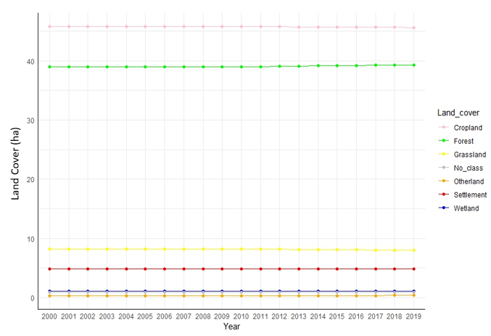
Figure 2. Serbia IPCC land cover types by hectare during the period 2000-2019.
(Color lines depict the different land cover types analyzed in the report)
There were some tiny changes in the areas on each land cover type during the evaluated period; however, in Figure 2, it is difficult to note. To provide a more detailed analysis of the changes, Figure 3 provides more focus at the cover class level.
In these new figures, it is easier to note that forests, other lands, and settlements show a slight increase in land cover from 2009 onward. In contrast, pastures and crops show a decrease in land cover.
Again, it is essential to highlight that in this report, the IPCC forest class differs from the forest category defined in Serbia's NFI2 field campaign. Areas designated as forest and other wooded lands (OWL) in the NFI2 are included as forests in this IPCC land cover analysis.
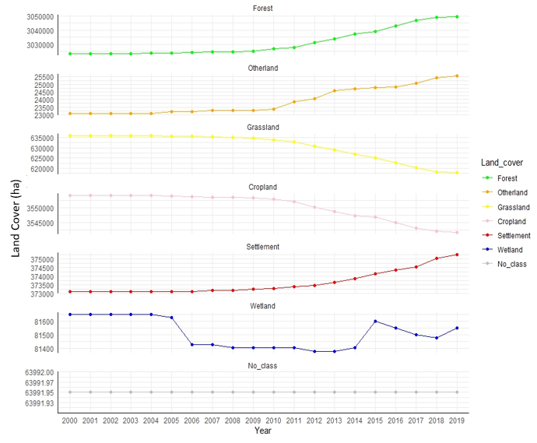
Figure 3. Serbian IPCC land cover classes hectares from 2000-2019.
(Color lines depict the different land cover types analyzed in the report).

Figure 4: Forest cover in Serbia in year 2000, 2005, 2010, 2015 and 2019

Figure 5: Forest cover absolute increment in hectares from different periods of time.

Table 7: Land Cover changes in Serbia, from year 2005 to 2019
IPCC CLASSES
Land Cover 2019
IPCC CLASSES  Land Cover 2005 | No Class | Cropland | Forest | Grassland | Otherland | Settlement | Wetland | Total
No Class | 63,991.9 | 0.0 | 0.0 | 0.0 | 0.0 | 0.0 | 0.0 | 63,991.9
Cropland | 0.0 | 3,540,020.6 | 10,857.1 | 775.5 | 0.0 | 1,275.8 | 0.0 | 3,552,929.1
Forest | 0.0 | 775.5 | 3,019,404.4 | 2,326.6 | 1,551.1 | 475.3 | 0.0 | 3,024,532.8
Grassland | 0.0 | 775.5 | 18,887.4 | 614,778.0 | 775.5 | 475.3 | 0.0 | 635,691.8
Otherland | 0.0 | 0.0 | 0.0 | 0.0 | 23,265.9 | 0.0 | 0.0 | 23,265.9
Settlement | 0.0 | 0.0 | 0.0 | 0.0 | 0.0 | 373,029.2 | 0.0 | 373,029.2
Wetland | 0.0 | 0.0 | 0.0 | 0.0 | 0.0 | 0.0 | 81,128.2 | 81,128.2
Total | 63,991.9 | 3,541,571.7 | 3,049,148.9 | 617,880.1 | 25,592.4 | 375,255.6 | 81,128.2 | 7,755,283.9

Comparation of the results with other sources of information on Serbia forest cover.
Currently, there are different sources available of forest cover estimation for the Republic of Serbia, among them, it can be mentioned Copernicus´s CORINE Land Country (CLC-CLCC), the ESA, ESRI products, other such Global Forest Watch, Globe land and the Global Land Cover from ESA.
All those different estimates are based in different algorithms and protocols, based in global estimates, and most of the times have different tree or forest cover definitions.
The analysis presented in this report provides a new information for Serbia in terms of land cover analysis, based on data analyzed in the country, and collected by national experts. The results provide an estimate of the standard error of the estimates, that provides more accuracy to the results.
Product | Forest extent (ha) | Forest Area as a percentage (%) of the total area | Standard Error
ESA | 4,161,094 | 47.60
ESRI | 3,601,691 | 41.20
Forest /no Forest JAXA | 4,248,448 | 48.60
Forest /no Forest TanDEM-X | 2,460,663 | 28.10
GFC Hansen >=10% | 3,389,368 | 38.80
GFC Hansen >=20% | 3,234,242 | 37.00
GFC Hansen >=30% | 3,047,736 | 34.80
Global Land Cover ESA | 2,438,660 | 27.90
GlobeLand | 3,314,036 | 37.90
Serbia NFI2 Forest Cover (year 2019)  (Remote Sensing) | 3,049,499 | 39.10 | 0.1

Final comments
This report complements the final report on the National Forest Inventory of Serbia prepared by Pantic and Borota (2023). The authors focused solely on the field campaign analysis, including a systematic sampling design, as was done during the first National Forest Inventory.
The report can be used as a standalone product for the historical analysis of land cover changes in Serbia between 2000 and 2019. The exercise carried out with the Collect Earth tool was part of the new design for the improved National Forest Inventory in Serbia, which focuses on optimizing the time and cost for the implementation of fieldwork and improving the statistical significance of the results.
However, it can also be treated as a separate study, as it incorporates the analysis of a historical observation period based on free-access archives of imagery in Google Earth and Bing Maps. As the first phase was set up as a systematic grid of 310,000 sample points, it can produce a good representation of the land cover in Serbia during the analysis period.
For this analysis, a Simple Random Sampling estimator was used to provide the study of the results. The sampling data and the procedures for the calculation are available to the government, and they can be updated in the future for further analysis.
The annex includes a step-by-step procedure needed to achieve the standard error estimations for land cover areas as an .Rmd file that can be reproduced using R Studio.

Annex
1) .Rmd file with all the procedures to repeat the results using R Studio

https://www.fao.org/3/cb0064en/cb0064en.pdf
https://data.worldbank.org/
Food and Agriculture Organization of the United Nations. (2023). Contribution of Sustainable Forest Management to Low Emission and Resilient Development. Retrieved from https://www.fao.org/serbia/projects/detail/en/c/1375467/
https://openforis.org/tools/collect-earth/
Pantic Damjan, Dees Mathias, Borota Dragan. 2020. Methodology of the second national forest inventory of the Republic of Serbia. Food and Agriculture Organization of the UN. Internal report not published. Belgrade, 2020 (Serbian and English version). 185 pp

