Annex 2

Complementary document to the results of the Serbian Second National Forest Inventory
-Land Use Assessment using the two-phase sampling approach-

Project: GCP/SRB/002/GFF: Contribution of sustainable forest management to a low emission and resilient development in Serbia (FSP)

Prepared by:
Anibal Cuchietti (FAO, International Forestry Consultant)
David Morales-Hidalgo (Forestry Officer)
Javier García Pérez (International Forestry Consultant)

November 2023

Table of Contents
II. Background 3
III. About this report 4
IV. Two-phase sampling approach in a National Forest Inventory 4
V. Two-phase sampling land use results 6
VI. Explanatory note about the comparability of the results on the NFI2 report, the land cover and land use analysis 8
VII. Land cover area improvements with two-phase methodology 9

Background
The Food and Agriculture Organization (FAO) has partnered with the government of Serbia to implement the project GCP/SRB/002/GFF, “Contribution of Sustainable Forest Management to Low Emission and Resilient Development,” which has been approved by the Global Environmental Fund. The report of this mission is part of the overall implementation of this project.
According to the Forest Resources Assessment, Serbia is covered by forests, with an area of 2,722,218.84 hectares, accounting for approximately 31.1% of the country’s total land. The forest sector contributed 1.3% to the national GDP in 2019, including the value added by forestry and logging and the manufacture of wood and wood products. Over 1,498,000 hectares of forests are used for productive purposes. Regarding ownership, 53% of the forests are owned by the state, while the rest are privately owned.
The location of forests in hilly or mountainous regions poses challenges for effective forest management. Despite these challenges, Serbian forests are rich in genetic, species, and ecosystem diversity. The forests and shrublands featuring endemic woody plants are significant.
Serbia’s most significant environmental impacts are deforestation, forest degradation, and biodiversity loss, where illegal logging, forest fires, and impacts from agriculture are the primary drivers of these impacts.
Serbia's current national forest policy lacks quantified targets and specific guidance on forest carbon management and biodiversity conservation. There is a lack of comprehensive information management systems and limited capacities among institutions responsible for sustainable forest management. The project “Contribution of Sustainable Forest Management to a Low Emission and Resilient Development” aims to address these barriers and promote sustainable forest management by improving information systems, bringing 80,000 hectares of forests under sustainable management, and incorporating multi-sectoral priorities, including carbon sequestration and biodiversity conservation.
Under Component 1 of the project “Enabling Environment for Multifunctional Sustainable Forest Management,” an Integrated Forest Information System was established to provide users with easy access to information for both strategic and operational purposes. Output 1, “Methodology for Forest and Biodiversity Information Collection and Management,” has introduced a novel approach for data collection and analysis.
As part of Output 1, FAO supports Serbia in implementing a new National Forest Inventory Sampling Design, utilizing a two-phase sampling method. The first phase involves an analysis of the land cover of all sampling points using a 1km x 1km grid. This information was collected using visual interpretation of high-resolution free imagery available on the Google Earth and Bing platforms using the FAO - Collect Earth (CE) tool, and its results were used as a post-stratification variable for the second sampling phase.
The second phase uses a 4km x 4km sampling grid to sample forest structure variables in forest-related clusters. The two-phase sampling design includes the two sources of information, the land cover assessment (1x1 km) and the forest structure variables (4x4 km), which are data types necessary to perform the statistical analyses corresponding to a two-phase sampling with post-stratification. More details about the methodology implemented can be found in Pantic, Dees, and Borota (2020).

About this report
This report will present the results of the land use analysis in the Republic of Serbia using the two-phase sampling approach. It provides an overview of the methodological approach developed. All the procedures for the calculation are summarized in the .Rmd file that can be reproduced using R Studio.
It aims to be a complementary information for the NFI2 report produced by FAO 2023 on the Serbia´s second NFI. In FAO 2023 report, the field data was analyzed using a simple random design as it was performed during the first national forest inventory in Serbia, were only the field data collected during the field campaign were taken in consideration.
In this report, the original sampling design using an estimator based on two phase sampling design is included. The report will focus only on the land use analysis, the additional analysis for the other variables will be included in the Annex 3.

Two-phase sampling approach in a National Forest Inventory
The availability and accessibility of high-resolution spatial information have increased in recent years, leading to a growing tendency to use such information in national forest inventories. In this context, the two-stage sampling design has become essential in the new designs of national forest inventories (Ramírez et al. 2022).
In this design, the first sampling phase focuses on land cover analysis, using high-resolution imagery, LiDAR, or radar. With this information, it is easy to define the different strata for phase 2 for the field data collection. At the same time, it can provide accurate and detailed information on forest area and forest type (Tomppo et al., 2008). This process is efficient because it can be largely automated. In the second phase, a sample is selected from the preliminary sample using a more intensive and accurate measurement method, such as systematic sampling, which involves laying out a grid of sample points or transects and measuring all the trees or vegetation within a fixed distance or area.
An optimal national forest inventory aims to obtain estimates of forest extension and structure that meet specified precision goals for the least cost (Köhl et al., 2011). When applying a two-phase sampling design, the uncertainty statistical variables are obtained using a specific method to calculate the data variance. According to Mandallaz (2008), the mean value of any variable within a stratum (Ῡ_{h}) may be estimated by the sample mean of all phase-two points within that stratum (n_{h}).
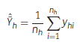
The estimated mean volume over all strata is then given by:
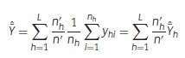
where L is the number of strata, n’ is the total number of phase-one points and n’_{h} is the number of phases one points within stratum h. The variance of the estimated mean within a stratum is estimated by:
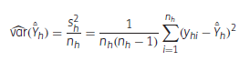
and the variance of the estimated overall mean, according to the infinite population approach (Saborowski et al., 2010), by:
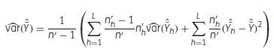
The two-phase sampling design has several advantages over other sampling designs. It is more efficient, cost-effective, and less time-consuming. It also provides more accurate and detailed information on forest area and forest type, which is essential for observing and managing critical environmental and socioeconomic trends. In addition, the design allows for early alerts and prompt assessments in case of impacts for wildfires and pests and diseases, among others.
The two-phase sampling design is an essential tool for sustainable forest management, as it helps optimize resource use and mitigate the effects of climate change.
The statistical indicators for the two-phase sampling design were assessed in the Serbian Second National Forest Inventory (NFI). Phase 1 plots are all plots of each cluster at grid 1km x 1km, and phase 2 plots are all the plots of each cluster at grid 4km x 4km.
The “forest inventory” package for R software was used to apply the “two-phase” function to obtain the statistical estimators for the area of the land cover types. For each level of the land use variable (each type of land cover defined in the Serbian NFI), it was necessary to create a “dummy” variable. This variable type can be defined as D = 1 for forest plots and/or clusters and D = 0 for the remaining land cover types. Such dummy variables divide the sample into an equal number of new variables (or sub-populations) as the land use types registered in the land use variable of the NFI.
All the procedures for the calculation are summarized in annex 1, where the .Rmd file can be imported and run in R Studio.

Two-phase sampling land use results
The results of the land use assessment using the two-phase sampling approach are summarized in Table 1 and Table 2.

Table 1: Percentage of land use in total and per region in Serbia, calculated using the two-phase sampling approach.
 | Vojvodina |  | Central Serbia |  | Total
LAND USE | Percentage | SE_% | Percentage | SE_% | Percentage | SE_%
Forest | 7.97 | 0.18 | 47.98 | 0.21 | 36.81 | 0.17
Other Wooded land (OWL) | 0.66 | 0.06 | 2.81 | 0.07 | 2.2 | 0.05
Other Land With Trees Cover (OLWTC) | 0.39 | 0.04 | 5.66 | 0.1 | 4.15 | 0.07
Barren land | 0.32 | 0.04 | 0.78 | 0.04 | 0.65 | 0.03
Agricultural land | 82.9 | 0.25 | 27.64 | 0.19 | 43.1 | 0.18
Meadows/pastures | 1.19 | 0.07 | 9.14 | 0.12 | 6.93 | 0.09
Built-up land | 4.53 | 0.14 | 5.12 | 0.09 | 4.95 | 0.08
Inland water | 2.04 | 0.1 | 0.88 | 0.04 | 1.21 | 0.04
*SE_%: Standard Error of the percentage
Table 2: Land use in hectares in Serbia and per region, calculated using the two-phase sampling approach.
 | Vojvodina |  | Central Serbia |  | Serbia
LAND USE | Hectare | SE_ha | Hectare | SE_ha | Hectare | SE_ha
Forest | 172 131.1 | 5 658.8 | 2 684 344.5 | 17 087.9 | 2 854 955.8 | 18 767.7
Other Wooded land (OWL) | 14 242.3 | 3 181.2 | 156 980.2 | 10 288.6 | 170 515.7 | 10 499.0
Other Land with Trees Cover (OLWTC) | 8 404.9 | 1 984.0 | 316 428.0 | 8 209.7 | 321 804.8 | 8 130.0
Barren land | 6 869.8 | 1 086.4 | 43 565.4 | 4 016.8 | 50 417.9 | 4 182.7
Agricultural land | 1 790 689.1 | 5 225.4 | 1 546 486.6 | 11 303.1 | 3 342 606.8 | 14 247.7
Meadows/pastures | 25 748.2 | 2 749.6 | 511 655.1 | 9 502.3 | 537 078.9 | 9 633.8
Built-up land | 97 938.4 | 3 000.2 | 286 268.9 | 5 539.9 | 384 273.6 | 6 374.1
Inland water | 44 034.3 | 2 376.9 | 49 498.9 | 2 643.3 | 93 632.2 | 3 604.1
TOTAL | 2 160 058.0 |  | 5 595 227.3 |  | 7 755 285.6
*SE_ha: Standard Error of the area
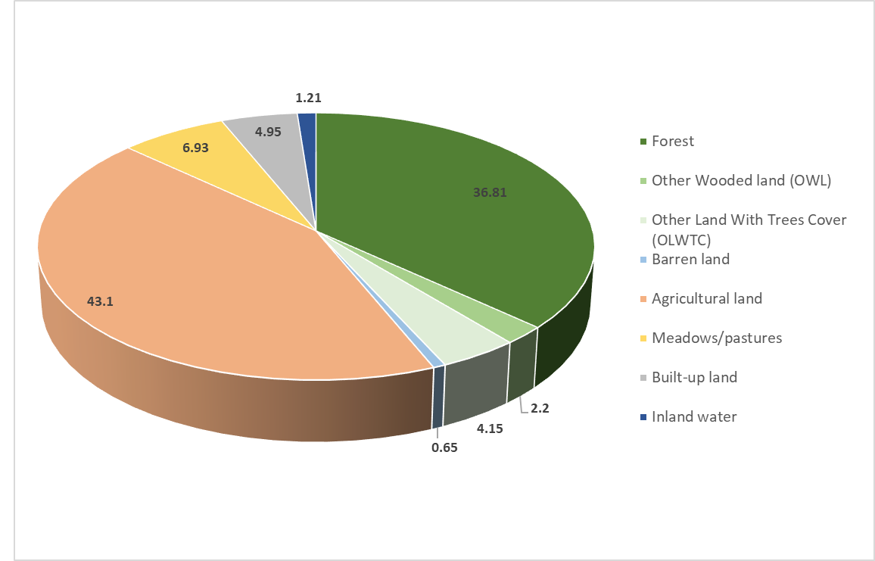
Figure 1: Percentage of area by land use

Explanatory note about the comparability of the results on the NFI2 report, the land cover and land use analysis
The forest cover/use assessment is not an easy task, and there are different approaches to carry out it described in the literature.
In the case of the second national forest inventory of the Republic of Serbia, three different approaches where tested:
- Forest Use: Using only the NFI field plots information. The results are summarized in the final NFI2 report. Unfortunately, no statistical significance was provided.
- Forest Use: Using the NFI field plot information and the Remote sensing data as auxiliary information integrated in the two-phase sampling approach.
- Forest Cover: Using the information from remote sensing data, using the FAO collect earth tool.
The three methodologies, provide similar information, but it is important again to recall the definition of Land Use and Land Cover included in the Annex 1.
For the first approach, all the results are summarized int the NFI report. It is important to note that in the NFI report, the total area of Serbia reported is 7,525,544 ha, which differs from the official area of 7,755,285 ha that was used in the calculation for the two-phase sampling approach and with the remote sensing data in this report.
Table 3 provides a short summary of the results comparison among the three different methodologies.
Table 3: Comparison of the results of Forest Cover / Forest Use assessment using the three different approaches implemented in the second national forest inventory in the Republic of Serbia that took place during the years 2019 - 2022.
 | Forest Use / NFI data using  Systematic sampling design.  2019-2022 | Forest Use / NFI data using  Two Phase sampling design.  2019-2022 |  | Land Cover  (Remote Sensing)  2019
 | Percentage  (%) | Percentage  (%) | SE_% | Percentage  (%) | SE_%
% of the area as Forest Use | 34.2 | 36.81 | 0.17 | n.a | n.a
% of Other Wooded Land (OWL) | 2.5 | 2.2 | 0.05 | n.a | n.a
% of Area with Tree cover | 36.7 | 39.01 | 0.22 | 39.3 | 0.1
At the level of forest use, the systematic approach, provides a slightly different estimate to the two-phase sampling approach. Unfortunately, the statistical significance was not provided, in terms of analyzing the similarities of both procedures.
In the Field data collection, the class of Other Wooded Land (OWL), was included to include areas present the thresholds of forest, but the land use is other than forest. Using this area, it can be possible to get an idea of the Forest cover/tree cover in Serbia, that can be compared with the Land Cover exercise using remote sensing analysis.
If Forest and OWL are compounded into one single category, the results show that the two-phase sampling approach is similar to the estimates from the land cover assessment using remote sensing, and it is clear that the systematic approach tends to sub estimate the Forest Land cover in Serbia.
Something important to highlight, is the low standard error reported in the two phase and remote sensing methods, which highlights the effectiveness of the new methodology suggested with the project.
Definily the reduction in the standard error, is playing an important role, when the reliability and the accuracy of the information is presented.

Land cover area improvements with two-phase methodology
Based on this report, it was possible to identify some suggestions to be implemented to improve the quality of the information and to guarantee a complete and repeatable data analysis process in the next cycles of the Serbian National Forest Inventory.
One of the best improvements of present report to the Serbian NFI2, it’s the step-by-step procedure needed to achieve the standard error estimations for land cover areas. This detail procedure is available as a .Rmd file that can be reproduce using R Studio.
The methodological improvements implemented in the NFI2 allowed to identify some forest regions where the number of sampling points of the 4km x 4km grid were not sufficient to perform reliable statistical analysis (e.g.: some regions and land covers with “NA” data). On the other hand, some regions and land cover types have a data variability higher than 10%, therefore it would be advisable to apply a future intensification of sampling plots to achieve a better characterization of the forest in those cases.
One of the innovations of Serbia’s NFI2 is the use of a 1km x 1km grid to assess the land cover. With this approach each grid point represents a total of 25 ha instead of 400 ha as in the 4km x 4km grid. This new grid allowed to detect areas covered by forest missed by the previous grid, resulting in a more accurate approach.
Figure 2, shows a map of Serbia forest cover built to compare the accuracy for detecting areas covered by forest with each grid’s scales, where green squares represent forest cover according to the 4km x 4km grid and light green squares the forest cover according to the 1km x 1km grid.
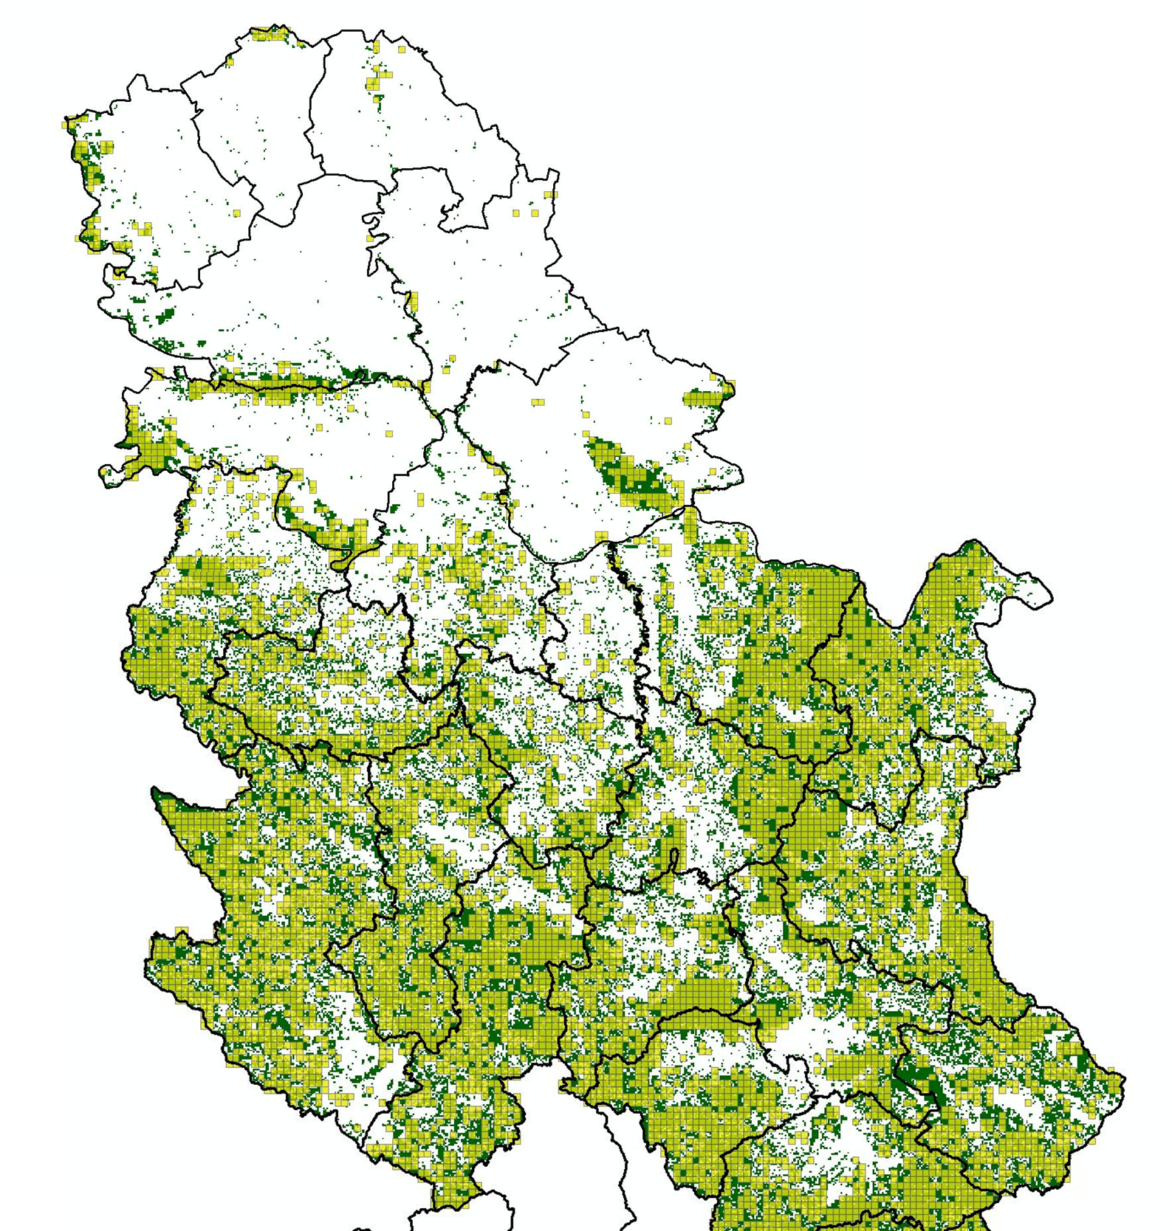
Figure 2: Representation of the 1x1 km clusters (light green), and 4x4 clusters (green) used in the NFI2 in Serbia.
As shown in Figure 2, the largest area of forest in the country is better detected by the sampling points of the 1x1 Km grid.

Annex
1) .Rmd file with all the procedure to repeat the results using R Studio

References
Cochran, W. G. (1977). Sampling techniques. John Wiley & Sons.
Köhl, M., et al. (2011). Sampling methods, remote sensing and GIS multiresource forest inventory. Springer Science & Business Media.
Mandallaz, D. (2008). Sampling Techniques for Forest Inventories. CRC Press.
Ramírez, C., Alberdi, I., Bahamondez, C. & Freitas, J. (2022). National Forest Inventories of Latin America and the Caribbean – Towards the harmonization of forest information. Rome, FAO. https://doi.org/10.4060/cb7791en
Saborowski, J., Marx, A., Nagel, J., & Böckmann, T. (2010). Double sampling for stratification in periodic inventories—Infinite population approach. Forest ecology and management, 260(10), 1886-1895.
Tomppo, E., Olsson, H., Ståhl, G., Nilsson, M., Hagner, O., & Katila, M. (2008). Combining national forest inventory field plots and remote sensing data for forest databases. Remote Sensing of Environment, 112(5), 1982-1999.

https://www.fao.org/3/cb0064en/cb0064en.pdf
https://data.worldbank.org/
Food and Agriculture Organization of the United Nations. (2023). Contribution of Sustainable Forest Management to Low Emission and Resilient Development. Retrieved from https://www.fao.org/serbia/projects/detail/en/c/1375467/
https://openforis.org/tools/collect-earth/
Pantic, D., Dees, M., Borota, D. (2020): Methodology of the Second National Forest Inventory of the Republic of Serbia. The Food and Agriculture Organization of the United Nations, Rome, 185 p.
Hill, A. and Massey, A. (2021). The R package forest inventory: design-based global and small area estimations for multiphase forest inventories. Journal of Statistical Software, 97(4), 1-40. doi:10.18637/jss.v097.i04
FAO 2023. Forest of Serbia: Results of the second National Forest Inventory. Internal report of the project GCP/SRB/002/GEF Contribution of sustainable forest management to a low emission and resilient development in Serbia (FSP). Belgrade, Republic of Serbia. 56 p (English version)

